Colourful Collembola: scale thickness and scale surface nanostructure work interchangeably to produce similar colouration in springtails.

Bram Vanthournout¹, Anastasia Rousaki², Thomas Parmentier⁴, Frans Janssens, Johan Mertens⁴, Peter Vandenabeele³, Liliana D’Alba¹, Matthew Shawkey⁴,

¹Evolution and Optics of Nanostructures Group, Department of Biology, University of Ghent, Ledeganckstraat 35, Ghent 9000, BELGIUM
²Raman Spectroscopy Research Group, Department of Chemistry, Ghent University, Krijgslaan 281, S12, B-9000 Ghent (Belgium).
³ Archaeometry Research Group, Department of Archaeology, Ghent University, Sint-Pietersnieuwstraat 35, B-9000 Ghent (Belgium).
⁴Terrestrial Ecology Unit, Department of Biology, University of Ghent, Ledeganckstraat 35, Ghent 9000, BELGIUM

Abstract.
Structural colors produced by cuticular scales in arthropods are well-studied, but most research thus far has focused on derived butterflies and beetles with distinct hues. A few recent studies suggested that the broadband golden colour of early butterfly and springtail scales was produced by either thin film interference or diffraction grating effects, but could not distinguish between them. To disentangle the effects of these two mechanisms, and thus, to gain crucial insight in the evolution of colour in early arthropod scales, we investigated colour production through body scales in seven springtail species that show a clear metallic iridescent colouration. Reflectance spectra of these seven species are largely uniform in that they exhibit a broadband metallic golden colouration with peaks in the violet-blue region. The colour production mechanism is an interplay between thin film and diffraction effects but is scale type dependent. In most spinulate scales, colour is produced through thin film effects. By contrast, scales with longitudinal ridges produce a metallic colour through diffraction effects. This indicates a remarkable tuning of scale colour using two separate mechanisms and suggests convergent evolution in early arthropod scales.
Keywords.
Scale colour, scale structure, Collembola, thin film, diffraction grating, optical modelling,
Introduction.
Colours can be divided into two broad categories. Pigments produce colours by selective absorbtion of some light wavelengths, while nanostructured tissues produce structural colours by light scattering and diffraction . In many arthropods, these structures are found in cuticular scales that produce an intense metallic and iridescent colouration (1). Scales are thought to have evolved from modified hairs and typically consist of a chitinous basal lamina adorned with longitudinal, continuous ridges. The valleys between these ridges can be smooth, or the ridges can be connected by crossribs (2, 3). Structrural colors in scales (4, 5) (e.g. thin films (6, 7), photonic crystals (8, 9), multilayers (6)) are well-studied. However, most of these studies have focussed on scales of extant, derived butterflies and beetles, leaving early Lepidoptera and other taxa largely unexplored. In particular, the early evolution of scales of basal arthropods, which have many scaled representatives (e.g. Archaeognatha, Zygentoma, Collembola) remains largely unknown. It is only recently that a handful of studies have shed some light on the mechanisms of colour production in early Lepidoptera. Investigating both fossil and extant members of the Micropterigidae (Lepidoptera) revealed a remarkably conserved pattern of scale nanostructures (10, 11), with the striking golden colouration resulting from a combination of thin film and diffraction grating (11). Kilchoer et al. (12) found that variation in thickness of the melanin - pigmented thin film scale was critical to color variation, while D’Alba et al. (10) demonstrated that the nanoscale crossribs between the longitudinal ridges produced golden colouration through a diffraction grating. This last study also investigated the colour of golden scales of the springtail (Collembola) Tomocerus vulgaris and identified pinpointed a diffraction grating as the main colour producing mechanism, but with longitudinal ridges in the absence of crossribs. It is therefore clear that the main colour mechanisms in a primitive scale design are thin films and diffraction gratings, but that their relative contribution and importance remains elusive. This needs further clarification to fully understand early scale evolution, particularly in non-Lepidopteran taxa.
Here, we explore the colour producing mechanisms of Collembolan scales. Springtails are ideal for investigation of the early evolution of scales. They are basal hexapods (13) of which some species are fully covered in body scales (14) that display metallic, iridescent colouration varying from distinctly golden to golden violet to silvery white/grey. These scales have attracted attention as since the early days of microscopy (15, 16) and their distribution and morphology are considered important taxonomic characters (17). Interestingly, scales have multiple independent origins in springtails (17, 18) and besides the typical scale type with longitudinal, continuous ridges Collembola exhibit a unique scale type with interrupted ridges in the form of triangular sail-like structures (see further) (19). As ridges have been identified as the main colour producing structure in one species of springtail (10) it is worthwhile investigating the effect of variation in scale surface topography as it likely directly impacts colour production.

We selected seven species of springtails to represent colour and scale ridge type variation: Lepidocyrtus cyaneus and Lepidocyrtus lignorum (golden violet, spinulate type), Cyphoderus albinus and Heteromurus nitidus (silvery white, spinulate), Heteromurus major (spinulate) and Pogonognathellus longicornis (silvery grey, continuous) and Tomocerus vulgaris (black/golden bands, continuous) and investigated colour production mechanisms using optical and electron microscopy, Raman spectroscopy, spectrophotometry and optical modelling to improve our understanding of basal scale design and its implications for colour production.

Materials and methods.
To investigate colour production in springtail scales we used scanning (SEM) and Transmission electron microscopy (TEM) to determine essential scale parameters and Raman spectroscopy to determine the presence of pigment in scales. These parameters are used as input for 3D models in FDTD (Finite-Difference Time-Domain) optical modelling that allows to investigate the contribution of each parameter to colour production. We compare these simulated reflectance spectra to measured spectra obtained by microspectrophotometry to determine the importance of thin film and diffraction grating effects.
Sample collection.
Individuals from the seven species were collected from two private gardens and one forest area in Belgium in spring and summer of 2018 (see table 1). Individuals from T. vulgaris and L. cyaneus originated from a lab-reared population in Ghent University. These individuals were kept in plastic containers (18 x 12 x 5 cm for T. vulgaris; 12 x 5 x 5 cm for L. cyaneus) with plaster added to the bottom. Springtails were fed with dried yeast in overabundance and provided with water by spraying once a week.
Table 1. Overview of the springtail species used in this study.
 | Locality | Latitude/Longitude | Colour
Lepidocyrtus cyaneus | Garden | 51.100750, 3.064969 | Golden violet
Lepidocyrtus lignorum | Forest (grass areas next to footpath) | 51.095639, 3.077721 | Golden violet
Cyphoderus albinus | Red wood ants nest | West-Vleteren | Silvery white
Heteromurus major | Garden | 51.092081, 3.062518 | Silvery white
Heteromurus nitidus | Garden | 51.092081, 3.062518 | Silvery grey
Tomocerus vulgaris | Garden | 51.100750, 3.064969 | Black/gold bands
Pogonognathellus longicornis | Forest (grassy area next to foothpath) | 51.095639, 3.077721 | Silvery grey

Scale morphology.
The whole body of scaled Collembola is covered with scales, including head, thorax and abdomen and in some species extending on the legs and antennae. In this study, we mainly focus on the scales on the dorsal side of the abdomen. Using SEM and TEM, we measured following five scale parameters that potentially have an effect on colour production: scale thickness, ridge base, ridge height, ridge distance and ridge length (figure 1).

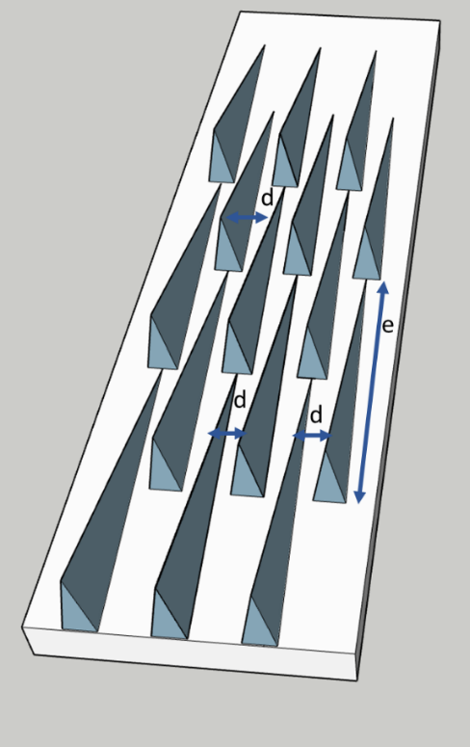
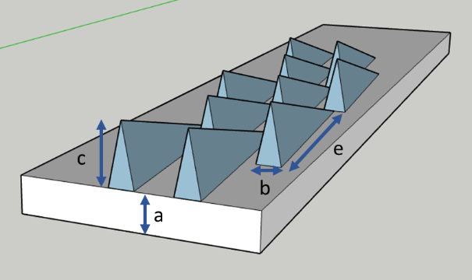
2
1

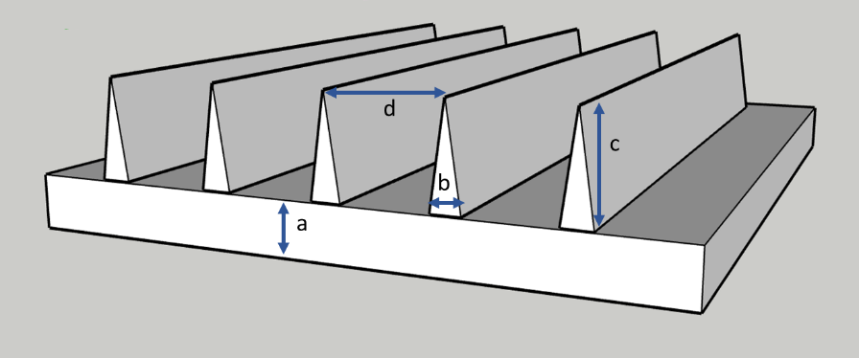
3

Figure 1. Schematic representation of scale parameters: scale thickness (a), ridge base (b), ridge height (c), ridge distance (d) and ridge length (e) for spinulate (1, 2) and continuous ridge (3) scale type. Figures produced in SketchUp.
For SEM, an entire individual was mounted ventral side down on an aluminium stub using double-sided carbon tape and coated with Au/Pd. Dorsal scales were viewed on a FEG-SEM (FEI Quanta 200F, Netherlands) under an accelerating voltage of 10kV and a working distance of 9.5 mm.
In SEM pictures, scales sometimes appeared to have overturned edges or are fully curled. This is likely an artefact of the SEM procedure as this phenomenon was not observed in live animals, TEM pictures or during microspectrophotometry measurements. We only measured uncurled areas for analyses.

For TEM, entire individuals were embedded following the protocol described in (20). Briefly, samples undergo two dehydration steps using 100% ethanol (20 min.) and go through an infiltration series with 15, 50, 70 and 100% Epon (24 h each step). Next, infiltrated individuals were placed in block moulds and polymerised for 16 h at 60°C. Thin cross sections were cut using a Leica UC-6 ultramicrotome (Leica Microsystems, Germany). Cross sections were stained in a Uranyless/lead citrate solution and examined on a JEOL JEM 1010 (Jeol, Ltd, Tokyo, Japan) transmission electron microscope.
Distances of scale thickness (TEM), ridge base (TEM), ridge height (TEM), ridge distance (SEM and TEM) and ridge length (SEM) were calculated using ImageJ 1.52 (21). For sample sizes, see table 3 in Results.

Scale pigment.
We used Raman spectroscopy to determine the presence and identity of pigments. A previous study found melanin in golden scales of T. vulgaris (10). We further investigated the presence of melanin on scales of T. vulgaris by mapping across part of a golden and black band and by point measurements on the scales of L. cyaneus.
All spectra were collected with a Bruker Optics Senterra dispersive Raman spectrometer coupled with an Olympus BX51 microscope and a motorized stage allowing the movement on the XYZ axis. The spectrometer is equipped with a diode laser (785 mm) and a green Nd:YAG (532 nm) laser and a thermoelectrically cooled CCD detector, operating at −65º C. Spectral ranges vary from 80–3500 cm⁻¹ for the 785 nm laser and 60–3709 cm⁻¹ for the 532 nm laser, with adjustable spectral resolutions of ∼ 3–5 cm⁻¹ and ∼ 8-19 cm⁻¹. The microscope turret uses magnifications at 5×, 20×, 50× and 100× with laser spot sizes 50, 10, 4 and 2 μm, respectively. The entire Raman system is controlled OPUS ® software.
The measurement conditions (laser power, accumulations and signal acquisition time) were adjusted for obtaining acceptable signal-to-noise (S/N) ratios. Post processing of the data was performed with Thermo Grams/AI 8.0 ® suite software (Thermo Fischer Scientific) while the Raman mappings were processed with OPUS ® software. For creating the micro-chemical images the ENArea (22) was used as a direct command of OPUS ® software.

Scale colouration.
We measured reflectance of the dorsal surface of scales both on the body and of single scales on glass slides at normal incidence using a CRAIC AX10 UV–Visible microspectrophotometer (CRAIC Technologies, Inc., USA) with Teflon tape as white standard. One measurement was taken per scale as some scales were too small for multiple measurements. For T. vulgaris, scales from golden and dark bands on the body were separately measured. For single scales originating from a black band, the melanin rich upper half of a scale was measured separately from the lower half. It was also noted that for T. vulgaris reflectance values below 400 nm were highly erratic and fluctuated during measurements. For this reason, we discarded measurements below 400 nm for this species.
Analysis and visualisation of the reflectance spectra was performed in R (version 4.0.2) (32) using the pavo package (23). For sample sizes, see table 2. We plotted reflectance spectra of single scales/bodyscales per species as well as calculated averages + 95% CI. To illustrate similarity between reflectance spectra of different species we plotted normalized averages (without CI) that allow a direct comparison. Furthermore, using the reflectance spectra as input, we also determined the colour space of single scales and body scales for our seven study species to investigate the extent of similarity (pavo package (23)). As visual model we used the segment colour space (31) as this provides an intuitive visualization in four segments that approximates a tetrachromatic system with ultraviolet, short, medium, and long-wavelength sensitive photoreceptors. Moreover, the segment colour space can be used with spectra of varying range, allowing to include the spectra of T. vulgaris that start at 400 nm.

Table 2. Overview of the number of scales used in microspectrophotometry for scales on body and single scales (number of scales / number of individuals). Number of individuals = 1 when not indicated.
Species | Scales on body | Single scales
Lepidocyrtus cyaneus | 15 / 2 | 17
Lepidocyrtus lignorum | 4 | 15
Cyphoderus albinus | 46 / 4 | 5
Heteromurus major | 11 | 10
Heteromurus nitidus | 14 | 11
Pogonognathellus | 4 | 17
Tomocerus vulgaris | 19 / 3 gold | 18 / 3 gold
 | 16 / 3 black | 16 / 3 upper half black
 |  | 16 / 3 lower half black

Cuticle colouration.
We investigated the potential effects on color of the cuticle underneath the scales by determining reflectance spectra of three T. vulgaris individuals through microspectrophotometry using the same methods as above. Similar to the scale banding pattern, the cuticle of T. vulgaris exhibits a dark/light banding pattern on the cuticle. Five measurements were taken in a light band and in a black band per individual (ten in total per individual). We used TEM pictures to assess the presence/absence of subcuticular melanin for all species.
Colour production mechanism using optical modelling.
To determine the contribution of thin film (scale thickness) and diffraction grating (ridge parameters) we used the Finite-Difference Time-Domain - (FDTD) modelling method using a commercial Maxwell equation solver from Lumerical Solutions, Inc. We used the dimensions obtained from SEM and TEM (see table 3 in Results) and the results of the Raman spectroscopy indicating the presence of melanin in the ridges to construct idealized 3D models in SketchUp. Models were constructed for scales and for both ridge types (spinulate and continuous).
For each species, three possible mechanisms for color production were tested (figure 2). Scale thickness only (thin film), ridges only (diffraction grating) and scale + ridges (thin film + diffraction grating). Refractive index of scales was set to chitin and the ridges to melanin, based on previously reported values (24, 25). The simulation space was consistently chosen to contain four ridge units wide and two ridge units deep (figure 3) for the spinulate type to include ridge variation. For the continuous ridge type, four ridge units were equally chosen. Simulation depth in this case does not influence the simulation as the ridges are continuously the same height. Perfectly matched layers (26) were used to absorb electromagnetic waves from both top and bottom of the simulation area and periodic boundary conditions on the side in order to simulate infinite periodic structures. The light source covered a 300 to 750 nm wavelength range and consisted of an unpolarized plane wave at normal incidence. Simulated reflectance spectra were visualized using the pavo package (23) in R (version 4.0.2) and plotted together with measured scale reflectance spectra (average ± 95% CI) to illustrate (dis)similarity.

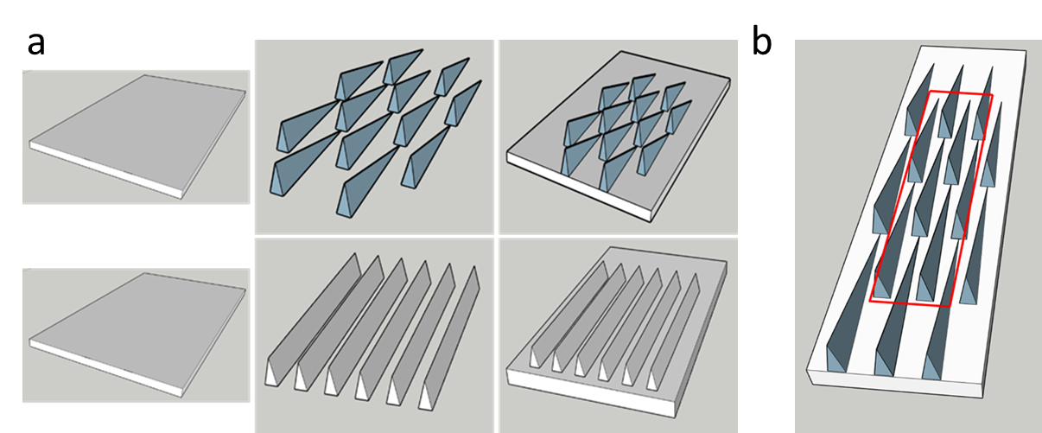

Figure 2. (a) Idealized 3D models of scales and ridge types (spinulate (top row) and continuous (bottom row)) in three scenarios: scale thickness only (left column), ridge only (middle column) and scale thickness + ridge (right column). (b) Width and depth of the simulation area.
We used simulations to investigate the additional effect of scale stacking on scale colour production: As scales are clearly stacked on the body, we investigated this effect by modelling one scale vs the stacking of two or three scales for the scale dimensions of L. cyaneus and T. vulgaris.

Collembola cladogram.
To illustrate the phylogenetic relationship between our study species and to illustrate the distribution of scale presence/absence in Tomoceridae and Entomobryidae we constructed a cladogram using a Bayesian phylogeny constructed by (18) (available online as Supplementary Tree 1 in Newick format). Heteromurus major and Heteromurus nitidus are already included in this phylogeny and we manually added our other study species to sister species of the same genus in the Newick file. We constructed a cladogram using the package ape (33) in R (version 4.0.2) by setting all distances to 0.
Results.
Scale morphology.
All investigated species are characterised by full covering of scales on the dorsal side of the abdomen. Scales show a clear stacking (rooftile manner) and vary greatly both between individuals of different species and within one individual in size and shape (see figure 4, 5). In SEM pictures, scales sometimes appeared to have overturned edges or are fully curled. This is likely an artefact of the SEM procedure (see Material and Methods section).
In this study, we focussed mainly on those scale parameters that potentially influence colour production. Scales can be broadly divided into two types, based on the nanostructures on the dorsal surface that are either spinulate or of the uninterrupted rib type (classification according to (19), figure 6). Spinulate scales have nanostructures in a herringbone pattern that consist of sail-like, triangular shaped structure when viewed from the side (supplementary figure 1). The uninterrupted rib type consists of continuous longitudinal and parallel ridges. Both types are oriented along the longitudinal axis of a scale and are, on cross section, characterised by a wide base that narrows towards the top. Ridges are generally electrondense as observed in TEM pictures (Figure xx), indicating presence of pigment (melanin, see further) while the basal lamina generally lacks pigment.
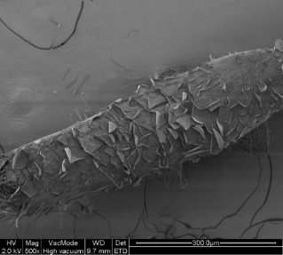
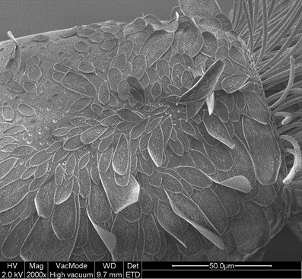
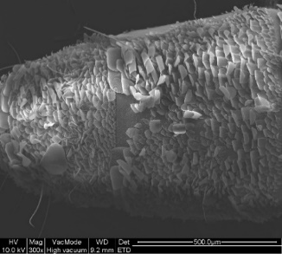
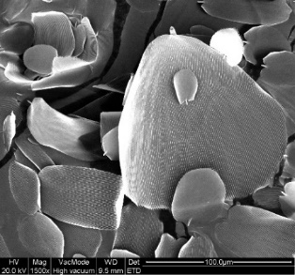

Figure 3. SEM images of the dorsal side of the abdomen of L. cyaneus (upper row) and T. vulgaris (lower row) showing the typical stacking and size/shape diversity of body scales.
We calculated the following scale parameters (see figure 4 and table 3):
- Ridge distance. The distance between the ridges is similar for L. cyaneus and L. lignorum (526 and 544 nm respectively), while ridges are more closely spaced in C. albinus. Highest ridge distance was found in H. major and H. nitidus (>900 nm) while T. vulgaris and P. longicornis demonstrated an intermediate ridge distance.
- Ridge length. This was only calculated for those species with a spinulate scale type as both T. vulgaris and P. longicornis have continuous longitudinal ridges. Two main classes of ridge length can be discerned: the ridges of L. cyaneus, L. lignorum and C. albinus are, on average, around 2 µm long, while the ridges of H. major and H. nitidus measure around 5 µm.
- Scale thickness. Similar to ridge distance, average thickness of a scale varies markedly between species but is relatively constant within genera. L. cyaneus and L. lignorum have the most thin scales, with H. major, H. nitidus and C. albinus having intermediate values of scale thickness. Scales with the highest thickness were found in T. vulgaris and P. longicornis.
- Ridge height. Height of the ridges seems to be the most variable parameter between species with L. cyaneus having the lowest ridges, followed by T. vulgaris. L. lignorum, C. albinus, H. major have intermediate ridge heights. Tallest ridges were found in P. longicornis and H. nitidus.
- Ridge base. The width of the ridge base varies from around 200 nm for L. cyaneus, L. lignorum, C. albinus and P. longicornis while being larger for T. vulgaris (270 nm) and over 300 nm for H. major and H. nitidus.
Table 3. Scale parameters for seven springtail species. Averages (nanometer) ± 95% CI are given together with number of scales/number of individuals. Number of individuals = 1 when not indicated. T. vulgaris and P. longicornis have uninterrupted longitudinal ridges, therefore ridge length is designated as “continuous”.
 | SEM |  | TEM
 | ridge distance | ridge length | scale thickness | ridge height | ridge distance | ridge base
Lepidocyrtus cyaneus | 526 ± 60 (8/2) | 2032 ± 123 (8/2) | 128 ± 16  (9) | 208 ± 19  (6) | 495 ± 40  (6) | 213 ± 14  (6)
Lepidocyrtus lignorum | 544 ± 81 (2) | 2260 ± 114 (2) | 131 ± 18  (7) | 491 ± 251 (4) | 748 ± 164 (7) | 231 ± 47  (4)
Cyphoderus albinus | 287± 36 (7) | 2118 ± 471 (7) | 294 ± 127 (2) | 478 ± 223 (2) | 175 ± 44  (2) | 166 ± 27  (2)
Heteromurus major | 920 ± 67 (5) | 5123 ± 168 (4) | 265 ± 34 (13) | 429 ± 81  (4) | 987 ± 105 (8) | 328 ± 27  (9)
Heteromurus nitidus | 945 ± 89 (3) | 5017 ± 725 (3) | 224 ± 22  (6) | 798 ± 124 (6) | 843 ± 49  (6) | 362 ± 43  (6)
Tomocerus vulgaris | 653 ± 74 (10/3) | continuous | 519 ± 91 (13/3) | 309 ± 42 (13/3) | 664 ± 94 (13/3) | 273 ± 35 (13/3)
Pogonognathellus longicornis | 787 ± 58 (13) | continuous | 663 ± 188 (4) | 675 ± 68  (4) | 712 ± 137 (3) | 210 ± 64  (3)

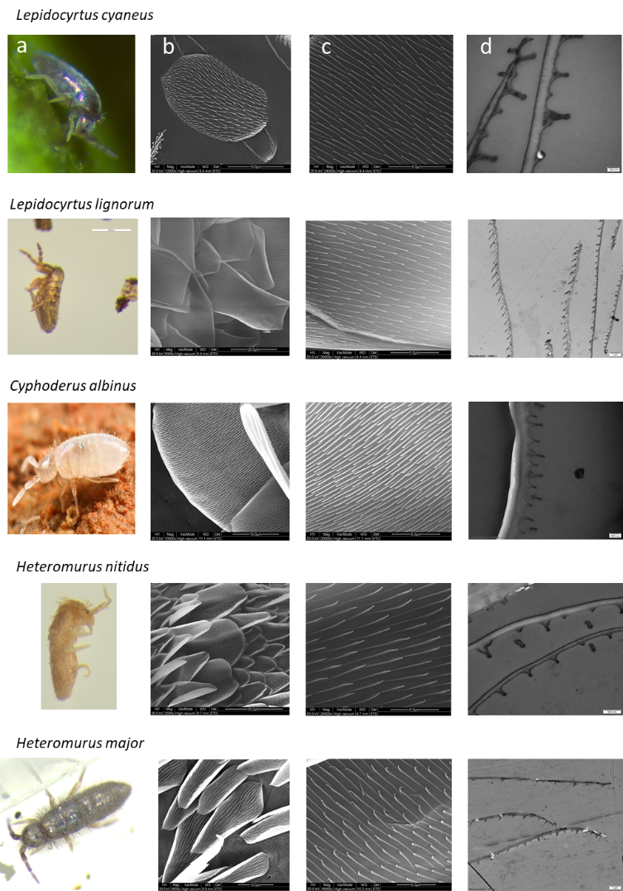
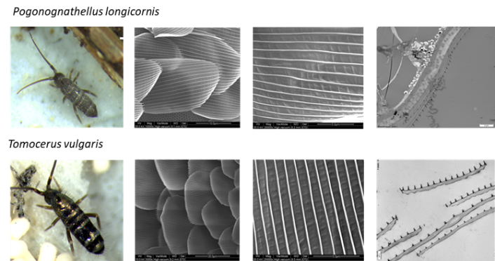
Figure 4. Macrophotograph (column a), SEM (column b and c) and TEM (column d) pictures of seven springtail species.
Scale colour.
Despite significant differences in scale parameters such as scale thickness and surface nanostructure topology, reflectance spectra of the different springtail species are surprisingly uniform, characterised by increasing reflectance towards the higher wavelengths resulting in a broadband silver to golden/metallic colour (figure 5, see supplementary figure 2 for reflectance spectra of measurements per scale for all species). Additionally, all species have, to some extent, reflectance peaks in the violet and/or blue/green region of the spectrum. Single scales exhibit higher reflectance, most likely due to reflectance-enhancing effects of the underlying glass slide. Besides this, scales on body and single scales general display similar reflectance spectra (see figure 5 and supplementary figure 3), however with some slight differences. L. cyaneus, L. lignorum and C. albinus seem to display a more pronounced peak at the lower wavelengths when single scales are measured compared to body scales (figure 5 and supplementary figure 2 and 3). This situation reverses in P. longicornis which has a more pronounced peak around 425 nm in scales on the body of P. longicornis vs singles scales. The similarity of the reflectance spectra can further be observed in the colour spaces for the different species that generally differ only little (figure 6), especially when measured on the body (figure 6b). C. albinus displays the highest variability with some points in colour space differing from all other species. For T. vulgaris, we measured scales from golden and black bands separately. Golden scales show a very high reflectance compared to other species, but also to the reflectance of black scales, which is likely caused by a difference in melanin content in the longitudinal ridges (see further). Similarly, a higher reflectance is observed in the lower half of a scale from a black band (low melanin content) compared to the lower reflectance of the upper half (high melanin content).

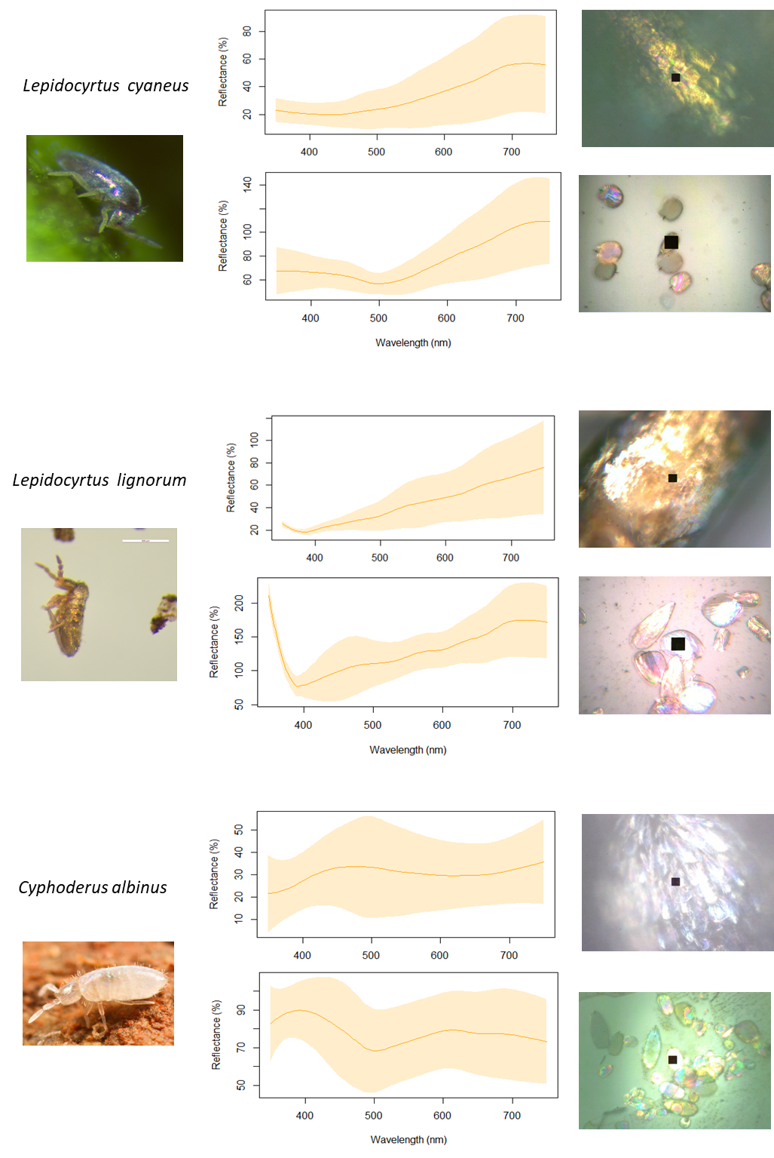

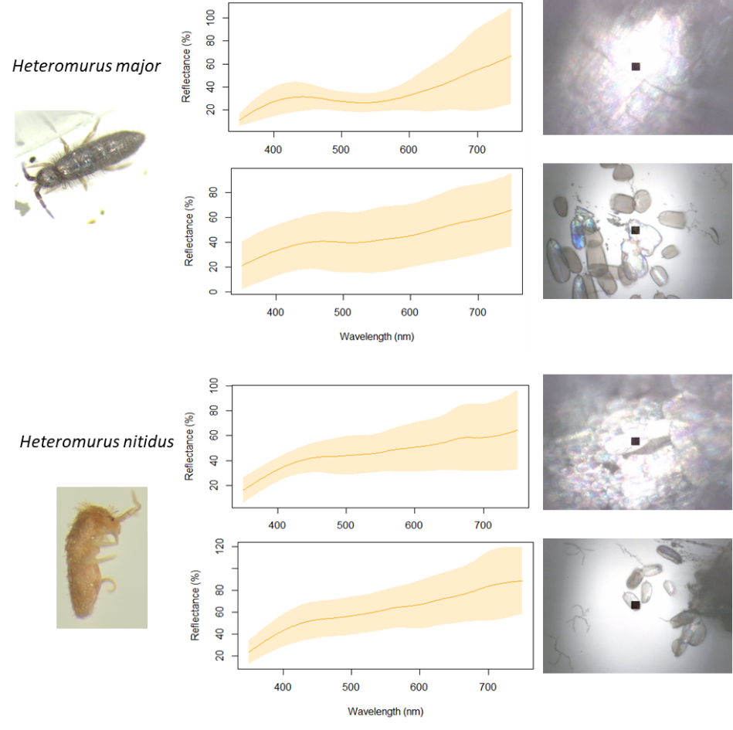

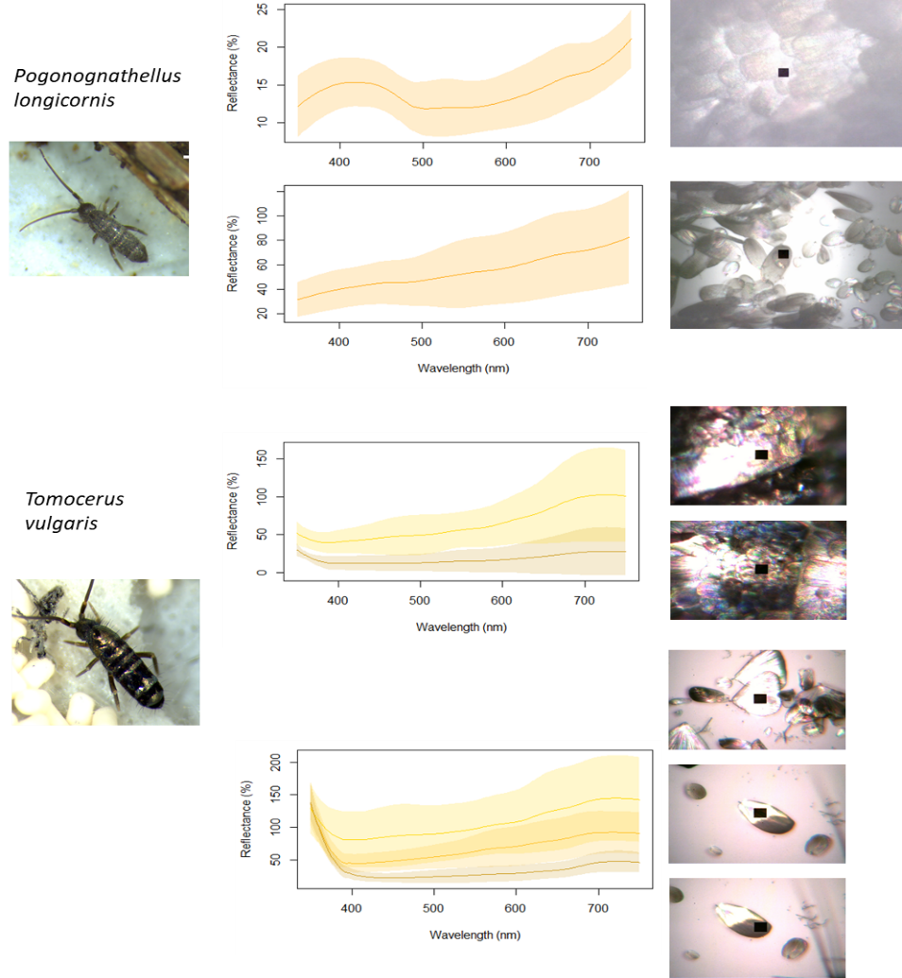
Figure 5. Measured reflectance spectra of scales on body (upper spectrum) or single scales on glass slide (lower spectra). For T. vulgaris, scales from golden (a) and dark (b) bands on the body were separately measured. For single scales originating from a black band, the melanin rich upper half of a scale was measured separately from the lower half.
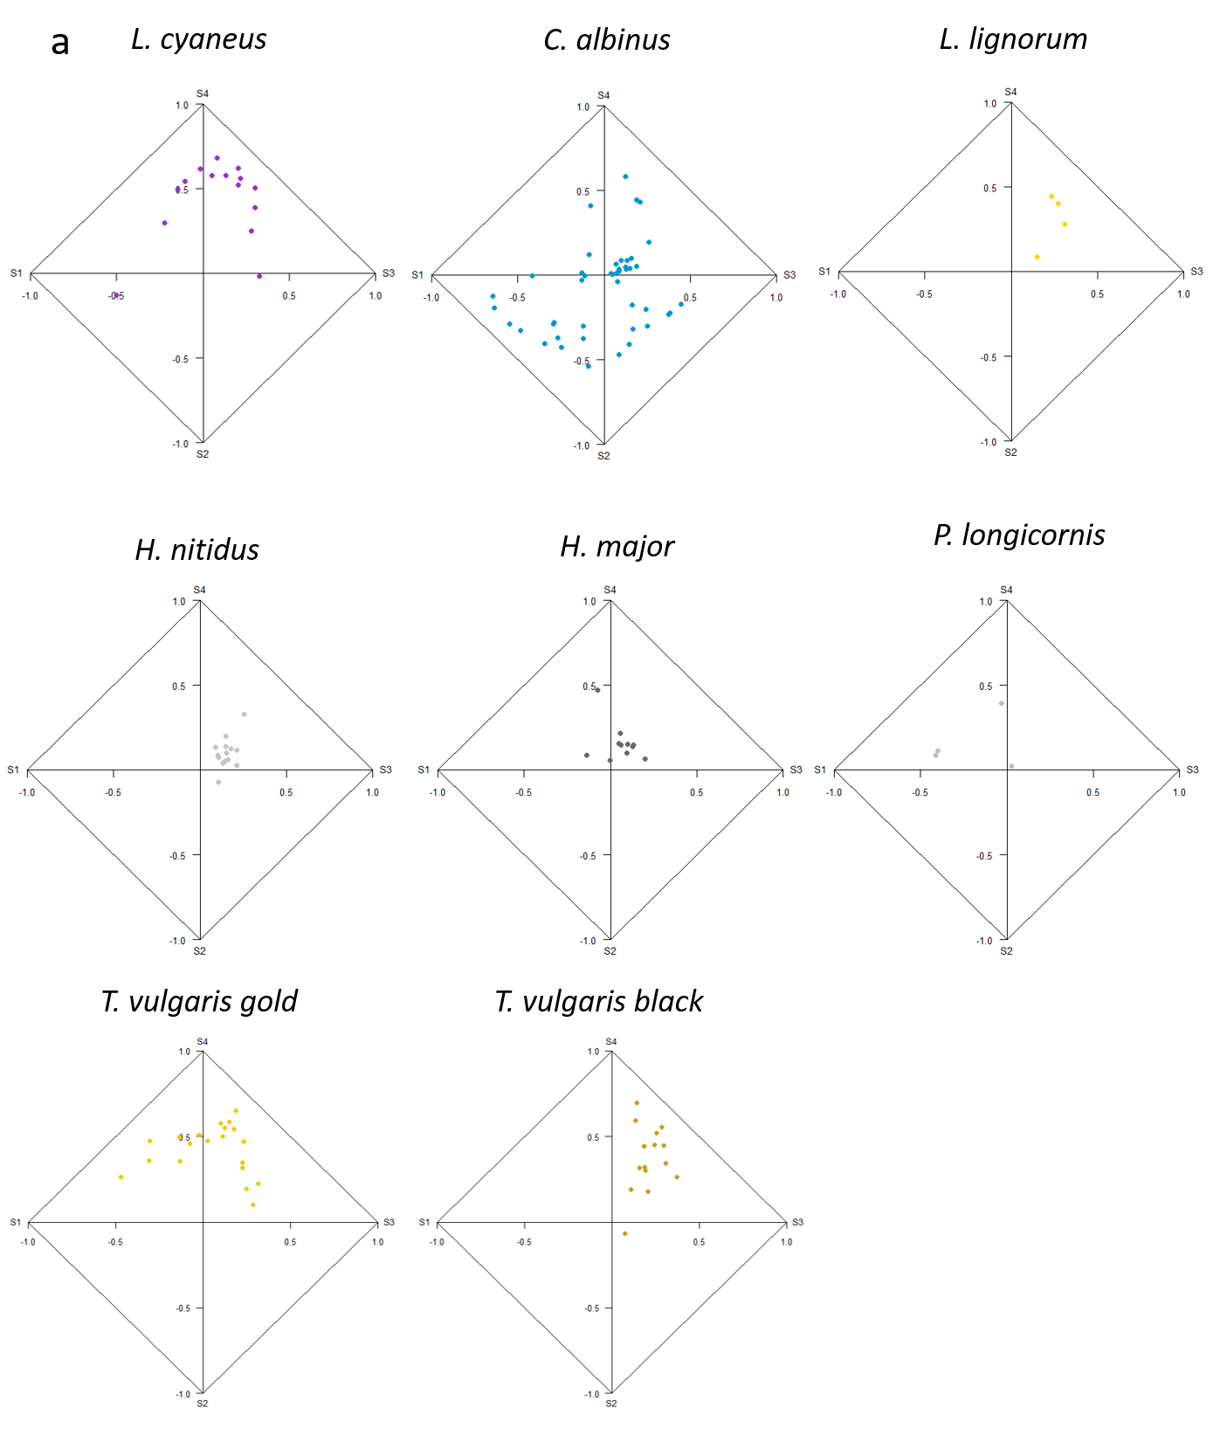

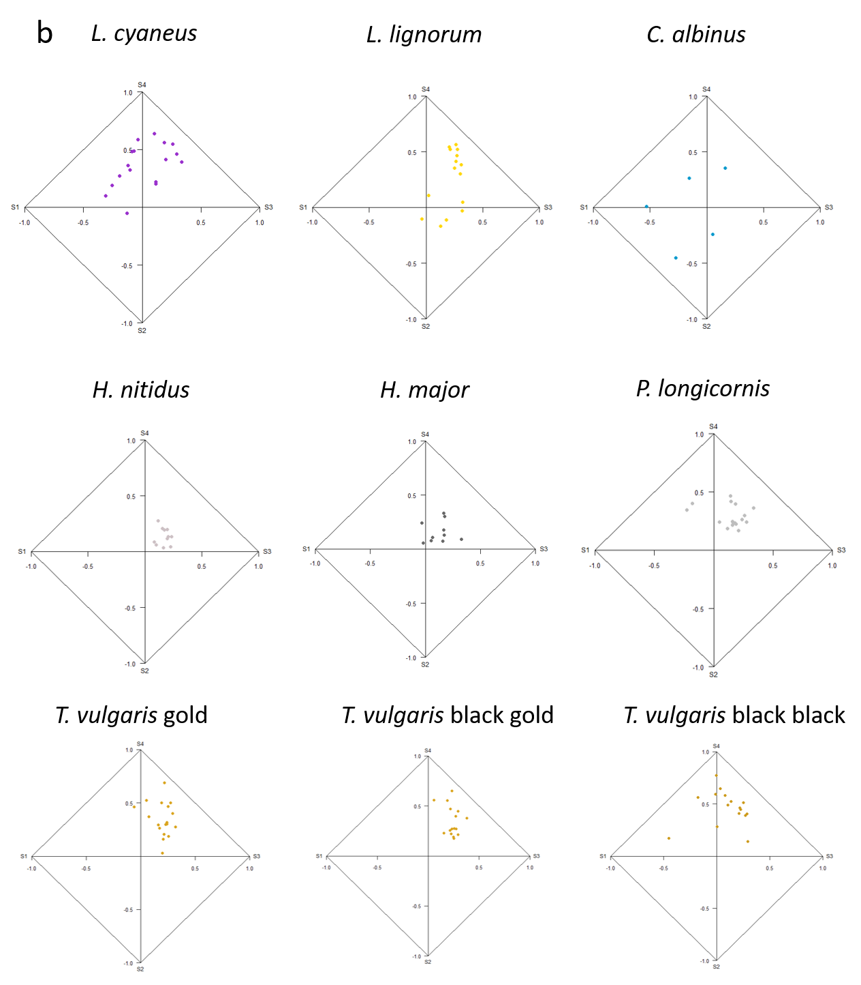

Figure 6. Segment colour spaces for scales on body (a) and single scales (b) for different springtail species. For T. vulgaris, scales from golden and dark bands on the body were separately measured. For single scales originating from a black band, the melanin rich upper half of a scale (T. vulgaris black black) was measured separately from the lower half (T. vulgaris black gold).
Scale colour production modelling.
To understand the importance of scale thickness and ridge structure and therefore to disentangle the effects of thin film and diffraction grating on colour production we designed idealized 3D models (table 4), based on the measured scale values of table 3.
Table 4. Scale parameters for idealized 3D models.
 | Scale thickness (nm) | Ridge height (nm) | Ridge length  (nm) | Ridge distance (nm) | Ridge base (nm)
Lepidocyrtus cyaneus | 130 | 200 | 2000 | 500 | 200
Lepidocyrtus lignorum | 130 | 700 | 2000 | 500 | 200
Cyphoderus albinus | 300 | 500 | 2000 | 250 | 200
Heteromurus major | 250 | 400 | 5000 | 900 | 300
Heteromurus nitidus | 250 | 800 | 5000 | 900 | 300
Tomocerus vulgaris | 450 | 300 | continuous | 700 | 300
Pogonognathellus longicornis | 700 | 700 | continuous | 800 | 200

We tested three hypothesized physical bases (thin film, diffraction grating, or a combination of both) for these colors by simulating the spectral reflectance of scale thickness only (thin film), ridges only (diffraction grating) and scale thickness + ridges (thin film + diffraction grating). These simulations indicate that both scale thickness (thin film) and ridge structure (diffraction grating) play a role but that the primary mechanism differs between spinulate and continuous ridge types. For the spinulate type of L. cyaneus (figure 7a), a scale of 130 nm (averaged across all measured scales) produces a thin film effect with high chroma in the UV part and an increasing reflectance towards the higher wavelengths, corresponding to a golden colour. This largely corresponds to the observed reflectance spectra of single scales (even more so for the reflectance spectra of scales on the body that are less right shifted, see figure 5). Moreover, a scale thickness of 140 nm which is within the 95% CI (128 nm ± 16, table 3) produces a better fit to the measured reflectance spectrum. By contrast, the ridges seem to play at most a limited role in producing a peak in the violet/blue region, pointing towards a general thin film effect in L. cyaneus. A similar pattern can be found in L. lignorum and C. albinus (supplementary figure 4). For C. albinus, single scales correspond well to the spectra obtained from modelled scale thin film, with peaks around 400 and 600 nm. In both species, simulations show that ridges likely play a minor role in single scale colour production, though it is striking that the ridges in C. albinus seem to produce a peak around 500 nm which is pronounced in reflectance spectra when scales are measured on the body (figure 5). In contrast, simulated reflectance spectra for the continuous ridges of T. vulgaris and P. longicornis (Figure 7c and 7d) both produce a broadband golden/silver colour and provide a far better fit with measured reflectance than thin film effects that produce multiple peaks across the spectrum. Measured reflectance spectra correspond strongly with this broadband golden/silver colour, suggesting that ridges are the main cause of scale colour.
Interestingly, while H. nitidus has spinulate type scales, simulations of scale thickness result in a spectrum with high UV and blue/green chroma, a poor fit to the observed spectrum. However, the ridge model produces a well-matching broadband metallic colouration, indicating a switch to ridge-based color production (figure 7b). For H. major, which has a similar scale thickness as H. nitidus, the pattern is less straightforward (supplementary figure 4), but it seems that diffraction grating through ridges, rather than thin film effects through scale thickness play a more important role.

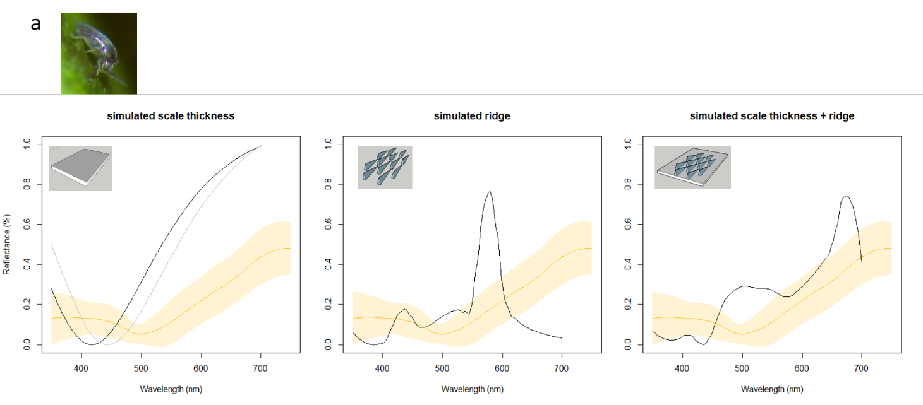
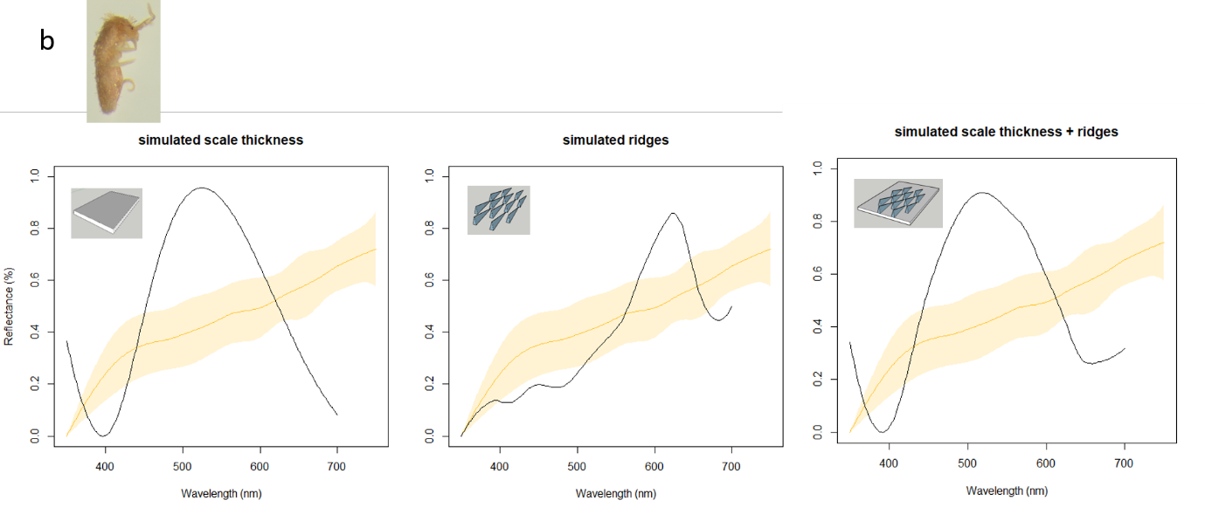
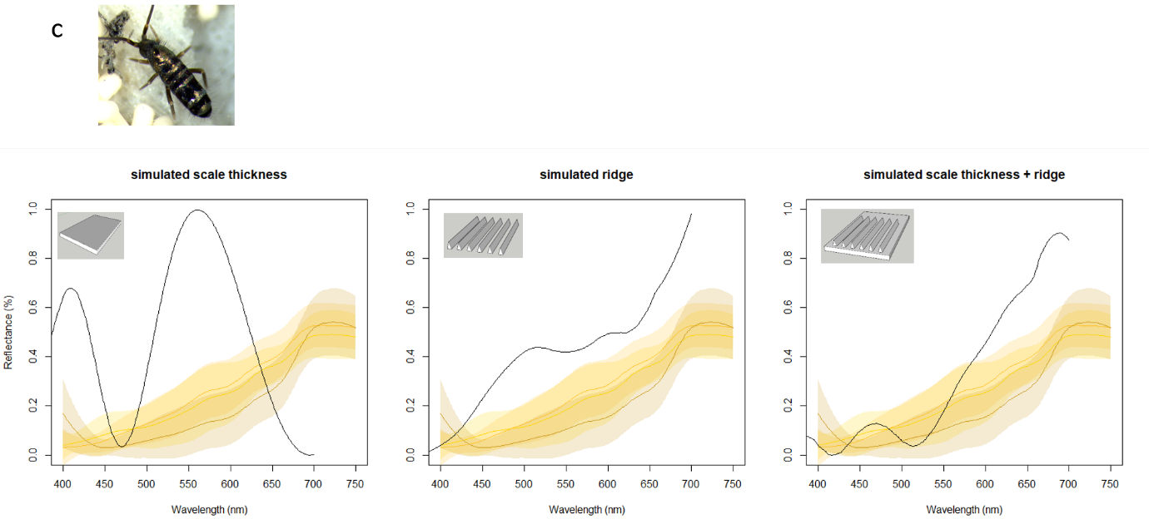
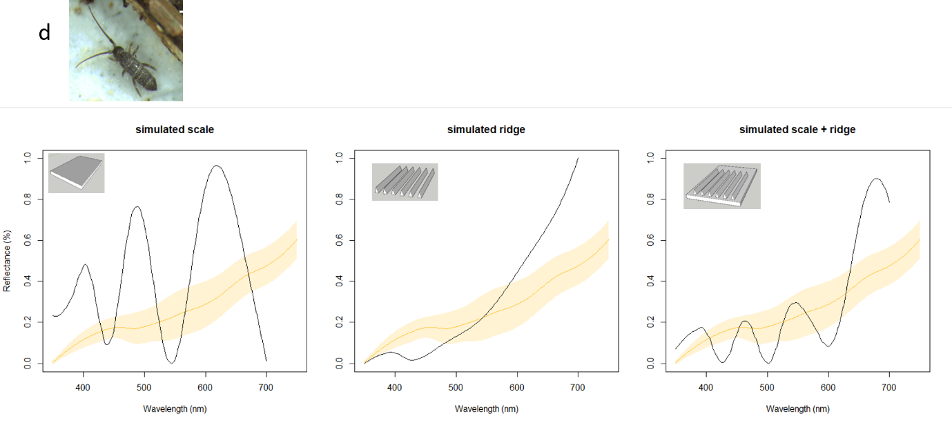
Figure 7. Scale thin film and ridge diffraction effects in scales of L. cyaneus (a), H. nitidus (b), T. vulgaris (c) and P. longicornis (d). Measured normalized reflectance spectra (average ± 95% CI) of single scales and simulated normalized reflectance spectra are plotted for scale thickness only, ridge only and scale thickness + ridge models.
Scale pigment.
Results of the Raman mapping experiment show two distinct areas represented by different colours in the map, corresponding to golden and black bands for T. vulgaris (Figure 8). Different coloured zones in the map correspond with different spectra from the scales. Both these areas indicate the presence of eumelanin (27, 28) with the difference in spectra likely being attributed to differences in eumelanin concentration though we cannot fully exclude the influence of focusing or fluorescence on the different measuring points, the contribution of other molecules present on the scales or a different quality (or crystallinity) of the pigment in the black and gold areas. Moreover, eumelanin was confirmed to be the main pigment in scales of L. cyaneus.

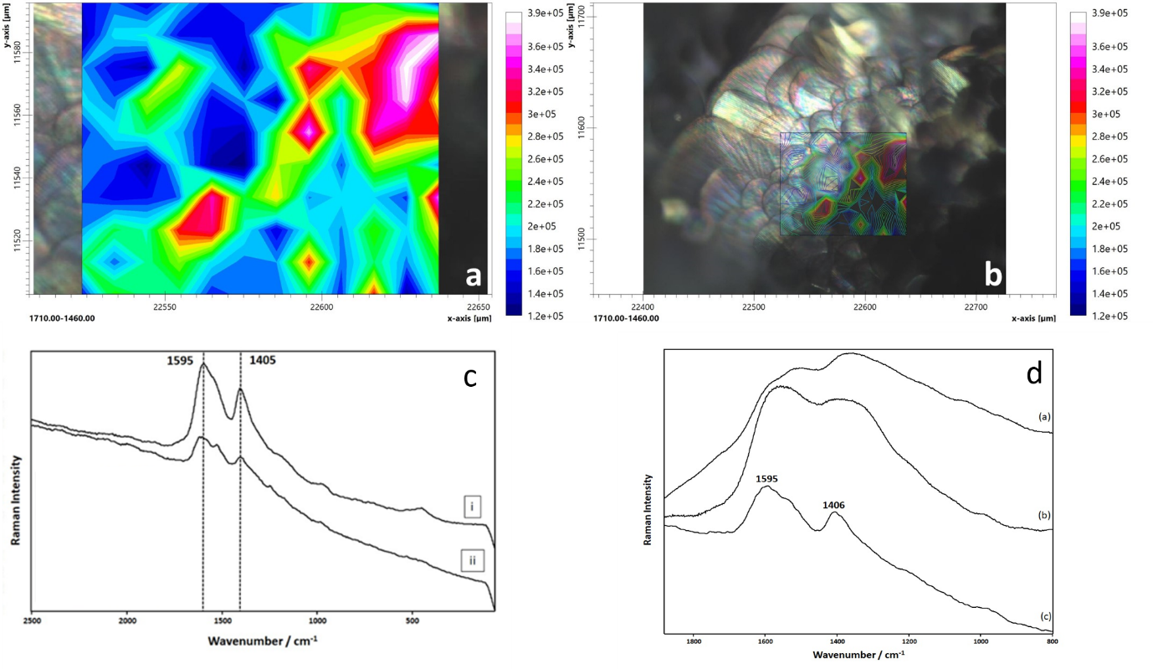
Figure 8. (a) Micro-Raman chemical mapping obtained by integrating the area at 1710-1460 cm⁻¹. The Raman mapping was performed on the boundaries between the two-coloured scales [rescaled to visualize the area in (b)]. The grid mapped consists of 120 points (10 × 12) with a step size of 10 μm. The experimental conditions for each point were 15 acc of 10 s, ∼9-18 cm⁻¹ spectral resolution, x20 magnification and measured with the 532 nm laser. (c) (i) denotes a black scale area, while (ii) denotes a golden scale area. (d) Representative spectra collected from (a) Sepia melanin with the 785 nm laser (200 acc of 120 s, ∼3-5 cm⁻¹ spectral resolution) (b) Sepia melanin with the 532 nm laser (60 acc of 30 s, ∼3-5 cm⁻¹ spectral resolution). (c) spectrum extracted from a mapping performed on the L. cyaneus scales (10 acc of 10 s, ∼9-18 cm⁻¹ spectral resolution).
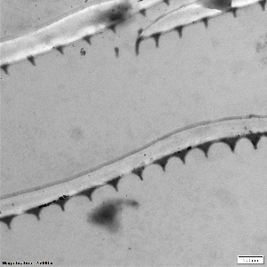
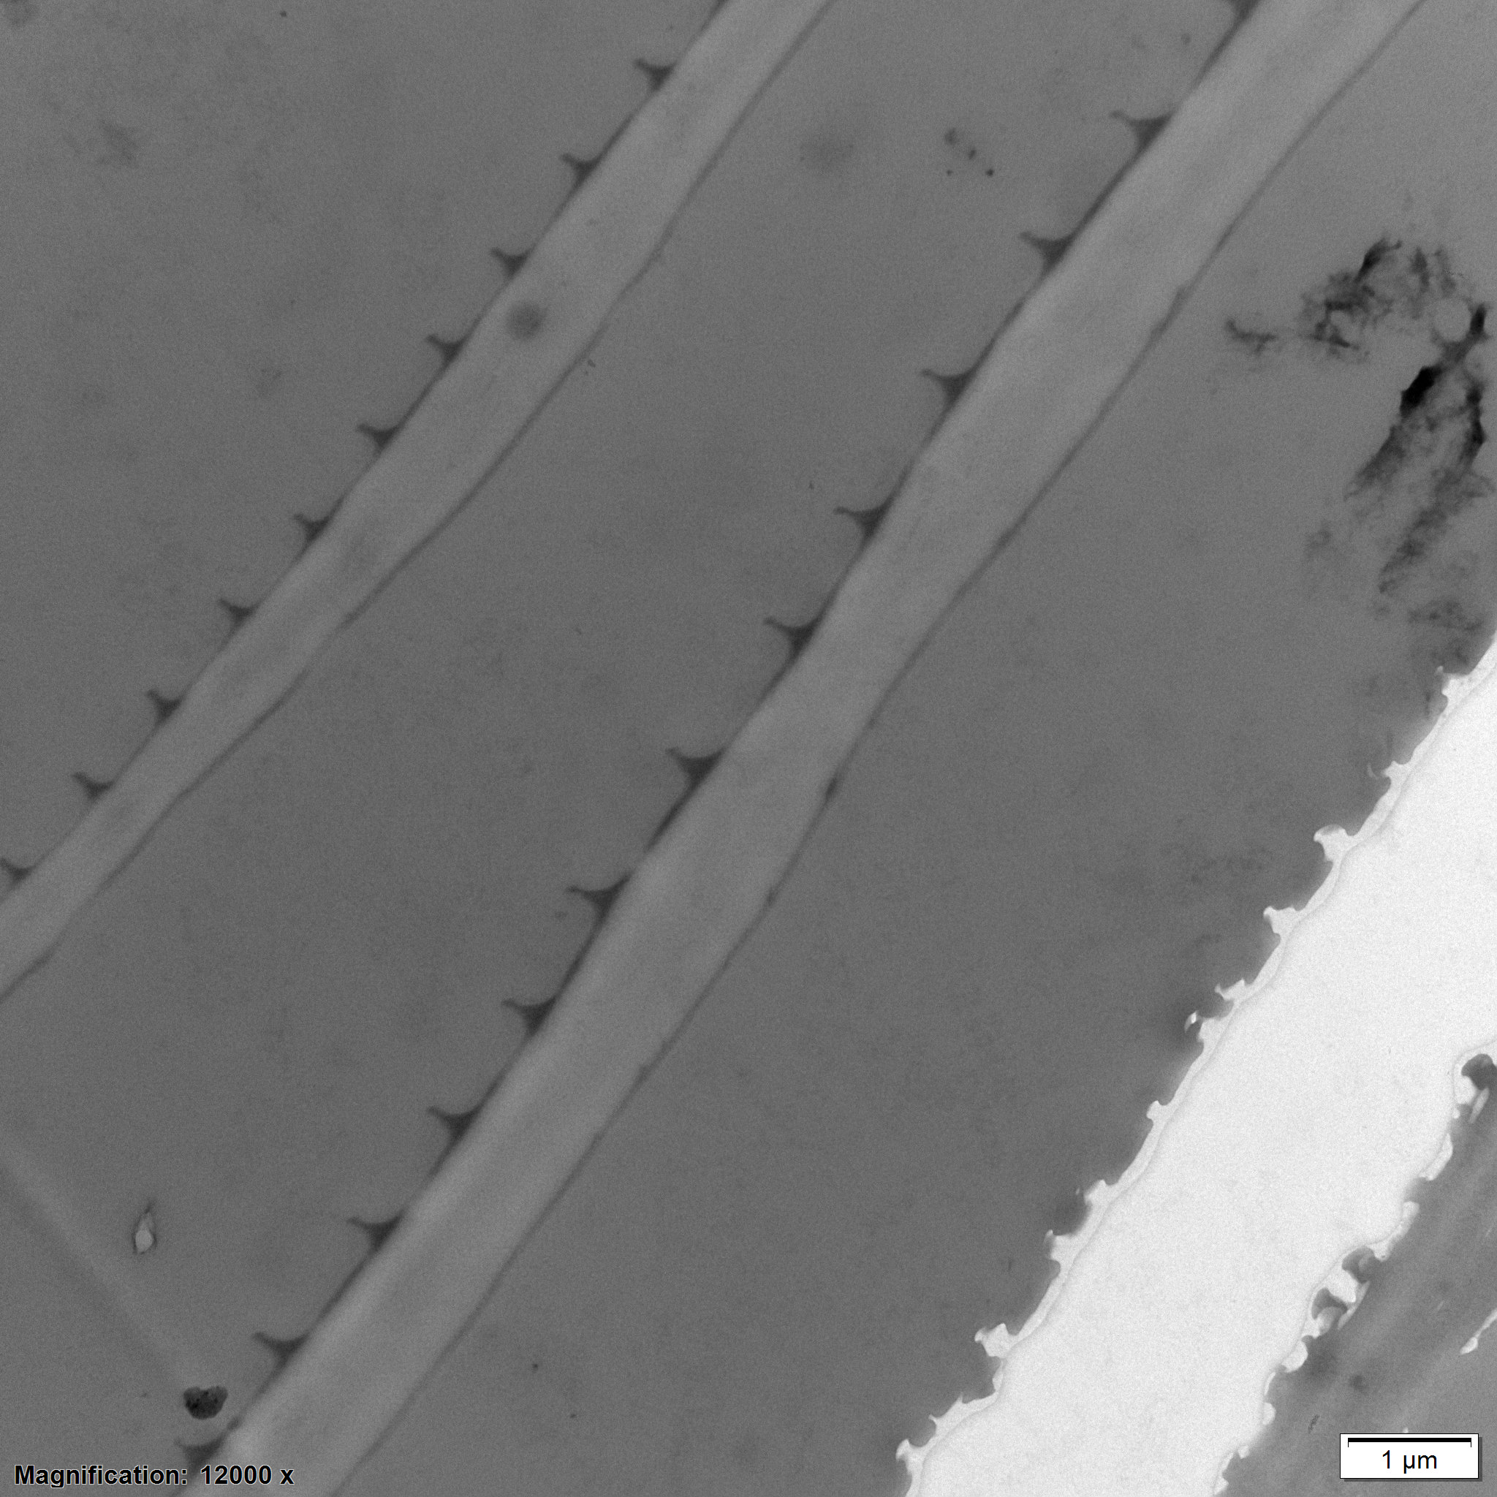
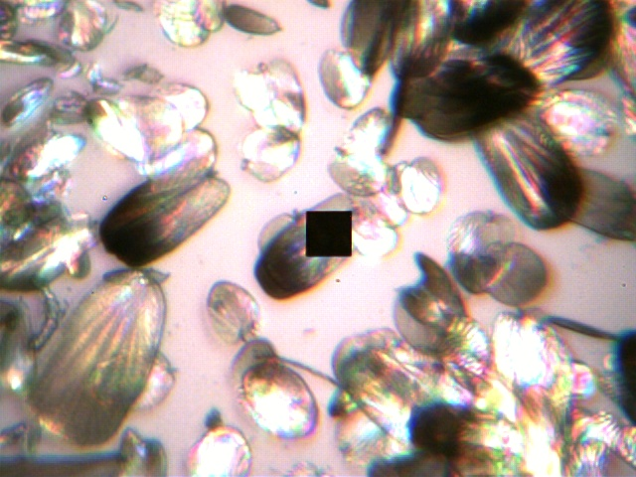
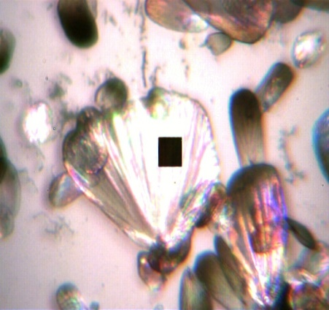
The effect of melanin in scales is the most apparent in the difference between scales of the gold and black bands of T. vulgaris (Figure 9). Golden scales have a lower melanin concentration compared to black band scales (figure 8) as well as a higher distance between ridges. The base of the ridges of black scales are touching, leaving ± 300 nm in between. Moreover, black band scales exhibit a clear gradient of melanin deposition, with higher amounts of melanin in the top half of the scale. Scales are stacked in such a way that only the high-melanin region is exposed. This results in lower reflectance (figure 5) and a general black appearance. This is also confirmed by optical modelling (supplementary figure 5)
a
b
c
d
Figure 9. TEM and microspectrophotometer pictures of black band (a, d) and golden band (b, c) scales of T. vulgaris. Electrondense ridges indicating melanin (a) and the melanin gradient (d) are clearly visible.
as increasing the ridge distance while keeping other scale dimensions of T. vulgaris constant seems to increase reflectance.

Scale stacking.
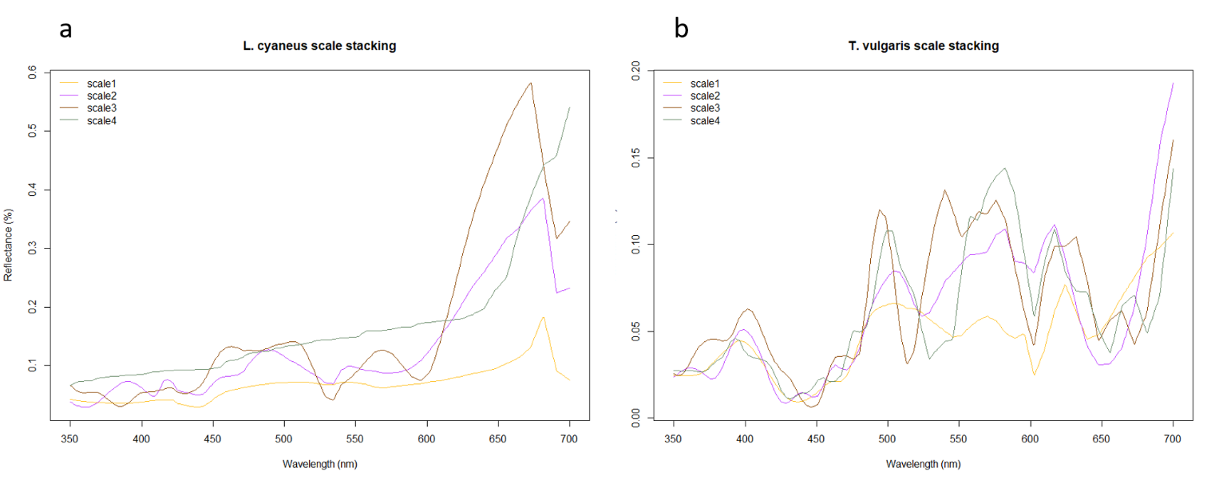
As we observe a clear stacking of scales on the body, we investigated this effect by simulating stacking of scales for L. cyaneus (spinulate type) and T. vulgaris (continuous ridge type). It appears that scale stacking has almost no effect on spectrum shape and has only a limited effect, slightly increasing

Figure 10. Simulated reflectance spectra of scale models with 1, 2, 3 or 4 scales for L. cyaneus (a) and T. vulgaris (b).
reflectance in L. cyaneus (figure 10). However, this does not seem to be an incremental process as stacking 2, 3 or 4 scales results in a similar reflectance. In T. vulgaris scale stacking seems to have an even more limited effect as almost no increase in reflectance is observed.
Cuticular colouration.
The cuticle of T. vulgaris exhibits a broadband metallic silver to golden colouration (Figure 11). Moreover, a banding pattern is observed that is opposite to the overlaying scale banding pattern. The beginning and middle of an abdominal segment has a vibrant golden colouration (overlaying scales are black) while the end of the segment seems to be more melanized and is characterised by a lower reflectance (while overlaying scales are golden) (Figure 11). The cuticle is further adorned with triangle shaped ridges arranged in a hexagonal pattern and a multilayer structure that both could influence colour production. Moreover, similar to melanin present in the scales, subcuticular melanin appears to have an effect on general appearance of individual springtails as those species with a silvery grey (H. major, P. longicornis) to black/golden (T. vulgaris) and purple (L. cyaneus) colouration have extensive melanin deposits underneath the cuticle (supplementary figure 6). In species that are silvery white (H. nitidus, C. albinus) to golden (L. lignorum) these deposits are largely absent.
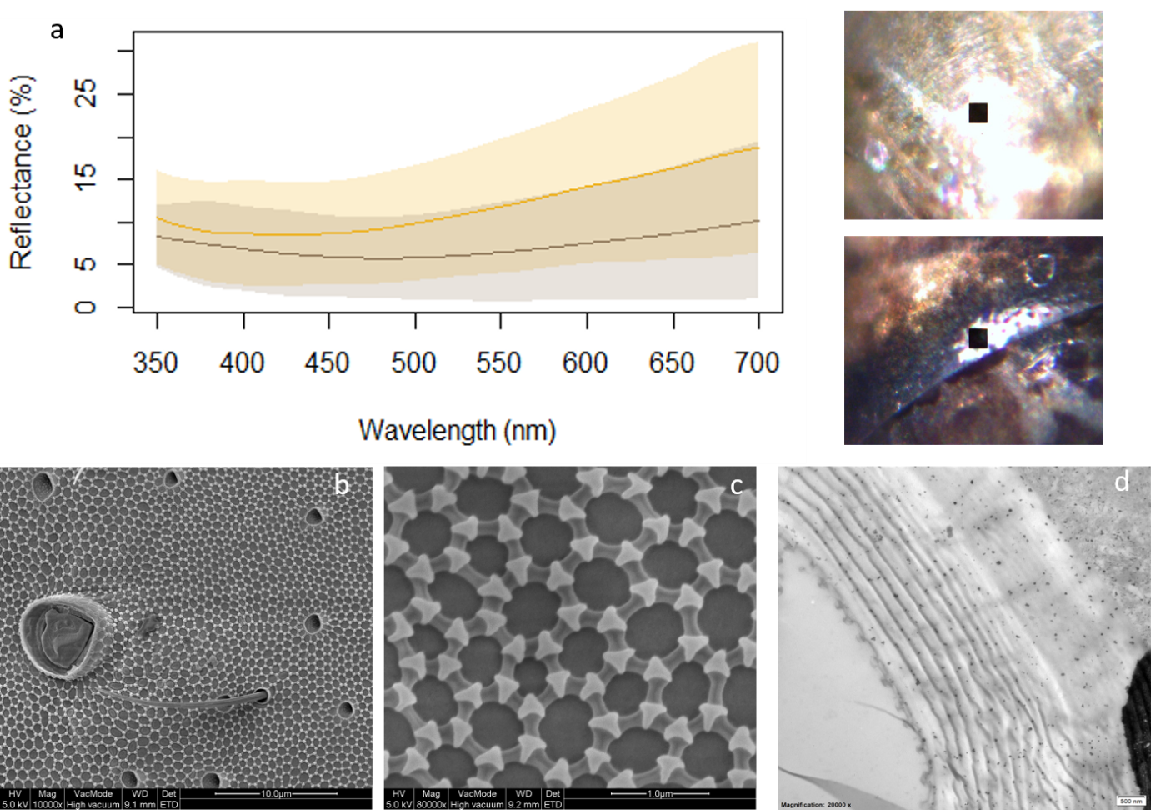
Figure 11. Reflectance spectra of the golden and melanised part of cuticle of T. vulgaris (a). SEM pictures of a descaled portion of the dorsal integument showing the hexagonal pattern of granules, overview (b), and higher magnification (c). TEM picture of the cross section of the cuticle of T. vulgaris with granules and a multilayer structure (d).

Discussion.
To gain insight into colour production by body scales in basal arthropods, we investigated the colour producing mechanisms of seven springtail species that differ in scale parameters such as thickness and scale surface topology (spinulate ridge type vs continuous ridges). Despite these morphological differences, all seven investigated species display a largely uniform metallic golden to silver colour with additional peaks in the violet/blue region. This is confirmed by segment classification analysis that visualizes the reflectance spectra into colour space, indicating a large proportion of overlap between species.
Reflectance spectra of single scales and of scales measured on the body are equally uniform, indicating that a single scale is the unit of colour production. There are, however, subtle differences when scales are measured on a glass slide or on the springtail body. It is noteworthy that those species (L. cyaneus, L. lignorum, C. albinus) that rely on thin film effects produced by scale thickness for colour have more pronounced peaks in the lower wavelengths when single scales are measured. This is far less the case for those species (T. vulgaris, H. nitidus, P. longicornis) that rely on ridges for colour production and is even reversed in P. longicornis. Either this is an artifact of measuring scales on a glass slide during, or scale stacking or cuticle play additional roles in colour production.
Optical modelling of scale stacking using the scale models of L. cyaneus and T. vulgaris indicate that scale stacking at most has a limited effect of increasing reflectance. Melanin deposits underneath the cuticle seem to have a far-reaching effect on the general appearance, e.g. producing grey appearance and by potentially enhancing the purple and golden colouration in L. cyaneus and T. vulgaris. We examined the cuticle of T. vulgaris in more detail and found that it exhibits a metallic colouration as well as what seem to be localized melanin deposits. The cuticle has an inverted colour pattern relative to scales: golden under black scales and dark under golden scales, potentially enhancing scale colour production. Cuticle colouration likely arises from a multilayer reflector or even from the granules found on the surface of the cuticle. These granules function as a hydrophobic barrier to protect the animal (), their role in colour production (if any) is currently unknown.
To elucidate the colour production mechanisms on single scales we performed optical modelling. We focussed on thin film (scale thickness) and diffraction grating (ridges) effects as these have been shown to be important in previous studies of Micropterigidae (10-12) and a springtail species (10). Our results confirm that thin film and diffraction grating are indeed the main drivers of colour in the scales of springtails. However, the main contributor to colour seem to differ between species and seems to be dependent on ridge type. In most of the species with scales of the spinulate type, scale colour is mainly produced by thin film effects, driven by a relatively small scale thickness (figure 7). The situation is reversed in species with a continuous, longitudinal ridge type. Here, the ridges largely produce colour through diffraction grating effects, and scale seem too thick to contribute to the observed colouration, as models predict multiple peaks across the reflectance spectrum for P. longicornis and T. vulgaris. L. lignorum represents an exception to this pattern: though L. lignorum has a spinulate ridge type, the simulated reflectance spectrum of the ridges resembles more that of a continuous ridge spectrum (figure 7). The dimensions of the ridges of H. nitidus might explain this pattern as the ridges are long (5 µm) and have the tallest height for spinulate ridges (800 nm). This suggest that, though spinulate, these ridges are optically similar to continuous ridges. The optical models therefore show that the ridges and not scale thickness produce the observed scale colour in L. lignorum. The ridges of H. major, which has spinulate ridges of similar length to L. lignorum (5 µm) but with a much smaller height (400 nm) do not produce a clear broadband golden colouration but instead have peaks around 450 nm and 650 nm, suggesting that the lower ridge height might be a limiting factor. Taken together, the results of the optical models indicate that scale thickness and surface nanostructure work interchangeably to produce highly similar colouration between springtail species.
There is a clear effect of melanin in the ridges, as indicated by the lower reflectance of the upper half of scales originating from the black bands in T. vulgaris (figure 5). Moreover, not only melanin, but also ridge distance reduce reflectance. Black scales of T. vulgaris have ridges of which the bases are almost touching leaving only 300 nm between ridge tops. Simulations indeed confirm that with decreasing ridge distance, reflectance reduces as well (Supplementary figure 5). This might also be the explanation behind the generally low reflectance of C. albinus who has the most densely spaced ridges of all investigated species.
While we employed two types of ridges (spinulate and continuous) in our analysis, two more scale types are currently recognized in Collembola: the short rib type (interrupted longitudinal ridges of similar length) and the long basal rib type (with long ridge at the base of the scale and interrupted ridges near the apex) (19). It would be most interesting to perform a similar analysis including these types and further elucidate the effect of ridge structure. Moreover, expanding our range and including other basal and scaled arthropods such as Archaeognatha and Zygentoma that all have continuous longitudinal ridges and metallic colouration holds enormous potential to investigate early scale colour production.
It is striking to note that, despite substantial differences in scale parameters such as scale thickness, ridge height, ridge distance, ridge length (spinulate type) and even ridge type (spinulate vs continuous ridges) the reflectance spectra of these seven species are largely similar and characterised by a broadband metallic golden to silver colour with clear peaks in the violet/blue region. This points to a certain degree of convergent evolution and similar selection pressures, especially as the spinulate and continuous ridge types have independent origins (18) (supplementary figure 6) though the evolution of scales remain uncertain in springtails. The function of scales in springtails is largely unknown. There is some evidence that the scales function as an antipredator mechanism (29) by readily detaching from the body, allowing the animal to escape. Scale structure, and especially the ridges, might be involved in mechanical strengthening of the scale. In this respect, it is interesting to remark that scales do appear to curl and bend due to SEM treatment, indicating that mechanical forces can have major impact. Curling seems to be more severe in scales with the spinulate type of ridges, which could indicate a higher strengthening effect of continuous ridges, especially as continuous ridges are found in larger species with larger scales. Lastly, the generally high reflectance of scales could point towards a role in thermoregulation by influencing the amount of reflected light. At least in one springtail species scale presence is seasonal and dependent on moulting stage, suggestion a potential link with environmental effects (30) .

References.

1. Ghiradella H. Insect Cuticular Surface Modifications: Scales and Other Structural Formations. In: Casas J, Simpson SJ, editors. Advances in Insect Physiology: Insect Integument and Colour. Advances in Insect Physiology. 38. London: Academic Press Ltd-Elsevier Science Ltd; 2010. p. 135-80.
2. H G. Hairs, bristles, and scales. In: Locke M, editor. Microscopic
Anatomy of Invertebrates 11A Insecta. New York - USA: Wiley-Liss; 1998. p. 257 – 87.
3. van Eldijk TJB, Wappler T, Strother PK, van der Weijst CMH, Rajaei H, Visscher H, et al. A Triassic-Jurassic window into the evolution of Lepidoptera. Science Advances. 2018;4(1).
4. Seago AE, Brady P, Vigneron JP, Schultz TD. Gold bugs and beyond: a review of iridescence and structural colour mechanisms in beetles (Coleoptera). Journal of the Royal Society Interface. 2009;6:S165-S84.
5. Mouchet SR, Vukusic P. Structural Colours in Lepidopteran Scales. Butterfly Wing Patterns and Mimicry. 2018;54:1-53.
6. Giraldo MA, Stavenga DG. Brilliant iridescence of Morpho butterfly wing scales is due to both a thin film lower lamina and a multilayered upper lamina. Journal of Comparative Physiology a-Neuroethology Sensory Neural and Behavioral Physiology. 2016;202(5):381-8.
7. Stavenga DG, Leertouwer HL, Wilts BD. Coloration principles of nymphaline butterflies - thin films, melanin, ommochromes and wing scale stacking. Journal of Experimental Biology. 2014;217(12):2171-80.
8. Galusha JW, Richey LR, Gardner JS, Cha JN, Bartl MH. Discovery of a diamond-based photonic crystal structure in beetle scales. Physical Review E. 2008;77(5).
9. Michielsen K, Stavenga DG. Gyroid cuticular structures in butterfly wing scales: biological photonic crystals. Journal of the Royal Society Interface. 2008;5(18):85-94.
10. D'Alba L, Wang B, Vanthournout B, Shawkey MD. The golden age of arthropods: ancient mechanisms of colour production in body scales. Journal of the Royal Society, Interface. 2019;16(159):20190366-.
11. Zhang QQ, Mey W, Ansorge J, Starkey TA, McDonald LT, McNamara ME, et al. Fossil scales illuminate the early evolution of lepidopterans and structural colors. Science Advances. 2018;4(4).
12. Kilchoer C, Steiner U, Wilts BD. Thin-film structural coloration from simple fused scales in moths. Interface Focus. 2019;9(1).
13. RG B, MI Y, Y M, M F, K M. The phylogeny of Hexapoda (Arthropoda) and the evolution of
megadiversity. Proc
Arthropod Embryol Soc Jpn. 2017;51:1 - 15.
14. Hawes TC, Greenslade P. A note on scale morphology in Collembola. Zootaxa. 2015;3925(4):594-6.
15. R B. On the scales of Lepidocyrtus ? hitherto termed Podura scales, and their value as tests, for the microscope. Trans Microscopical Soc. 1862;10:83 - 8.
16. EM N. On the Podura scale. J Royal Microscopical Society. 1907:393 - 404.
17. Zhang F, Sun D-D, Yu D-Y, Wang B-X. Molecular phylogeny supports S-chaetae as a key character better than jumping organs and body scales in classification of Entomobryoidea (Collembola). Scientific Reports. 2015;5.
18. Zhang F, Chen Z, Dong R-R, Deharveng L, Stevens MI, Huang Y-H, et al. Molecular phylogeny reveals independent origins of body scales in Entomobryidae (Hexapoda: Collembola). Molecular Phylogenetics and Evolution. 2014;70:231-9.
19. Zhang F, Chen J-X, Deharveng L. New insight into the systematics of the Willowsia complex (Collembola: Entomobryidae). Annales De La Societe Entomologique De France. 2011;47(1-2):1-20.
20. D'Alba L, Saranathan V, Clarke JA, Vinther JA, Prum RO, Shawkey MD. Colour-producing beta-keratin nanofibres in blue penguin (Eudyptula minor) feathers. Biology Letters. 2011;7(4):543-6.
21. Schneider CA, Rasband WS, Eliceiri KW. NIH Image to ImageJ: 25 years of image analysis. Nature Methods. 2012;9(7):671-5.
22. Lauwers D, Brondeel P, Moens L, Vandenabeele P. In situ Raman mapping of art objects. Philos Trans A Math Phys Eng Sci. 2016;374(2082).
23. Maia R, Eliason C, Bitton P, Doucet S, Shawkey M. pavo: an R package for the analysis, visualization and organization of spectral data. Methods in Ecology and Evolution. 2013;4(10):906-13.
24. Leertouwer HL, Wilts BD, Stavenga DG. Refractive index and dispersion of butterfly chitin and bird keratin measured by polarizing interference microscopy. Optics Express. 2011;19(24):24061-6.
25. Stavenga DG, Leertouwer HL, Hariyama T, De Raedt HA, Wilts BD. Sexual Dichromatism of the Damselfly Calopteryx japonica Caused by a Melanin-Chitin Multilayer in the Male Wing Veins. Plos One. 2012;7(11).
26. Berenger JP. A PERFECTLY MATCHED LAYER FOR THE ABSORPTION OF ELECTROMAGNETIC-WAVES. Journal of Computational Physics. 1994;114(2):185-200.
27. Galván I, Jorge A, Ito K, Tabuchi K, Solano F, Wakamatsu K. Raman spectroscopy as a non-invasive technique for the quantification of melanins in feathers and hairs. Pigment Cell Melanoma Res. 2013;26(6):917-23.
28. Galván I, Jorge A, Solano F, Wakamatsu K. Vibrational characterization of pheomelanin and trichochrome F by Raman spectroscopy. Spectrochim Acta A Mol Biomol Spectrosc. 2013;110:55-9.
29. Wolff JO, Schoenhofer AL, Schaber CF, Gorb SN. Gluing the 'unwettable': soil-dwelling harvestmen use viscoelastic fluids for capturing springtails. Journal of Experimental Biology. 2014;217(19):3535-44.
30. Hawes TC. The unusually colourful "clothing' changes of Lepidophorella australis Carpenter, 1925 (Collembola: Tomoceridae). New Zealand Entomologist. 2017;40(1):22-9.
31. Endler, John A. 1990. “On the Measurement and Classification of Colour in Studies of Animal Colour Patterns.” Biological Journal of the Linnean Society 41 (4): 315–52. https://doi.org/10.1111/j.1095-8312.1990.tb00839.x.
32. R Core Team (2020). R: A language and environment for statistical computing. R Foundation for Statistical Computing, Vienna, Austria. URL https://www.R-project.org/.
33. Paradis E, Schliep K (2019). “ape 5.0: an environment for modern phylogenetics and evolutionary analyses in R.” Bioinformatics, 35, 526-528.

